EXP NO:

DATE:

AIM:

PROCEDURE:

CODE:
<!DOCTYPE html>
<html lang="en">
<head>
<title>230191601037</title>
<meta charset="UTF-8" />
<meta name="viewport" content="width=device-width, initial-scale=1" />
<title>Online MCQ Test with Timer</title>
<link rel="preconnect" href="https://fonts.googleapis.com">
<link rel="preconnect" href="https://fonts.gstatic.com" crossorigin>
<link href="https://fonts.googleapis.com/css2?family=Poppins:wght@400;600&display=swap" rel="stylesheet">
<style>
body {
font-family: 'Poppins', sans-serif;
max-width: 800px;
margin: 0 auto;
padding: 20px;
background-color: #eef2f7;
color: #333;
}
h1 {
text-align: center;
color: #2c3e50;
margin-bottom: 30px;
}
#timer {
font-weight: 600;
font-size: 18px;
margin-bottom: 20px;
color: #c0392b;
text-align: right;
background-color: #fff;
padding: 10px;
border-radius: 8px;
box-shadow: 0 4px 15px rgba(0,0,0,0.05);
}
.question, .question-review {
background-color: white;
padding: 20px;
margin-bottom: 20px;
border-radius: 8px;
box-shadow: 0 4px 15px rgba(0,0,0,0.08);
border: 1px solid #ddd;
}
.options {
margin-top: 15px;
}
.options label {
display: block;
margin-bottom: 10px;
padding: 12px;
border: 1px solid #ccc;
border-radius: 5px;
cursor: pointer;
transition: background-color 0.3s, border-color 0.3s;
}
.options label:hover {
background-color: #f8f9fa;
border-color: #007bff;
}
button {
background-color: #007bff;
color: white;
padding: 12px 25px;
border: none;
border-radius: 5px;
cursor: pointer;
font-size: 16px;
font-weight: 600;
display: block;
margin: 20px auto 0;
transition: background-color 0.3s, transform 0.2s;
}
button:hover {
background-color: #0056b3;
transform: translateY(-2px);
}
button:disabled {
background-color: #888;
cursor: not-allowed;
transform: none;
}
#result {
margin-top: 20px;
font-weight: bold;
}
.correct {
border-left: 5px solid #28a745;
}
.incorrect {
border-left: 5px solid #dc3545;
}
</style>
</head>
<body>
<h1>Online MCQ Test</h1>
<div id="timer">Time Left: 02:00</div>
<form id="quizForm">
<div class="question" id="q1">
<p>1. In which state is the Sun Temple of Konark located? 🏛️</p>
<div class="options">
<label><input type="radio" name="q1" value="a"> Kerala</label>
<label><input type="radio" name="q1" value="b"> Tamil Nadu</label>
<label><input type="radio" name="q1" value="c"> Odisha</label>
<label><input type="radio" name="q1" value="d"> Rajasthan</label>
</div>
</div>
<div class="question" id="q2">
<p>2. Who is known as the "Father of the Indian Constitution"? 📜</p>
<div class="options">
<label><input type="radio" name="q2" value="a"> Mahatma Gandhi</label>
<label><input type="radio" name="q2" value="b"> Jawaharlal Nehru</label>
<label><input type="radio" name="q2" value="c"> B. R. Ambedkar</label>
<label><input type="radio" name="q2" value="d"> Sardar Vallabhbhai Patel</label>
</div>
</div>
<div class="question" id="q3">
<p>3. What is the capital of Tamil Nadu?</p>
<div class="options">
<label><input type="radio" name="q3" value="a"> Madurai</label>
<label><input type="radio" name="q3" value="b"> Coimbatore</label>
<label><input type="radio" name="q3" value="c"> Salem</label>
<label><input type="radio" name="q3" value="d"> Chennai</label>
</div>
</div>
<div class="question" id="q4">
<p>4. Which river is also known as the "Ganges of the South" (Dakshina Ganga)? 🌊</p>
<div class="options">
<label><input type="radio" name="q4" value="a"> Godavari</label>
<label><input type="radio" name="q4" value="b"> Krishna</label>
<label><input type="radio" name="q4" value="c"> Kaveri</label>
<label><input type="radio" name="q4" value="d"> Narmada</label>
</div>
</div>
<div class="question" id="q5">
<p>5. When did India gain independence from British rule?</p>
<div class="options">
<label><input type="radio" name="q5" value="a"> 1950</label>
<label><input type="radio" name="q5" value="b"> 1947</label>
<label><input type="radio" name="q5" value="c"> 1942</label>
<label><input type="radio" name="q5" value="d"> 1921</label>
</div>
</div>
<button type="button" onclick="submitQuiz()">Submit Quiz</button>
</form>
<div id="result"></div>
<script>
let timeLeft = 120;
const timerDiv = document.getElementById('timer');
const countdown = setInterval(() => {
const minutes = Math.floor(timeLeft / 60);
const seconds = timeLeft % 60;
timerDiv.textContent = `Time Left: ${minutes.toString().padStart(2, '0')}:${seconds.toString().padStart(2, '0')}`;
if (timeLeft < 0) {
clearInterval(countdown);
alert("Time's up! The quiz will now be submitted.");
submitQuiz();
}
timeLeft--;
}, 1000);
function disableQuiz() {
document.querySelectorAll('input[type=radio]').forEach(input => input.disabled = true);
document.querySelector('button').disabled = true;
}
function submitQuiz() {
clearInterval(countdown);
disableQuiz();
const answers = {
q1: 'c',
q2: 'c',
q3: 'd',
q4: 'a',
q5: 'b'
};
let score = 0;
const totalQuestions = Object.keys(answers).length;
for (let question in answers) {
const selected = document.querySelector(`input[name="${question}"]:checked`);
if (selected && selected.value === answers[question]) {
score++;
}
}
document.getElementById('quizForm').style.display = 'none';
let resultHTML = `<h2>Your Score: ${score} out of ${totalQuestions}.`;
if (score === totalQuestions) {
resultHTML += ' Perfect! Well done!';
} else if (score >= totalQuestions * 0.8) {
resultHTML += ' Great job!';
} else if (score >= totalQuestions * 0.6) {
resultHTML += ' Good effort!';
} else {
resultHTML += ' Keep studying!';
}
resultHTML += '</h2><div class="review">';
for (let i = 1; i <= totalQuestions; i++) {
const qid = `q${i}`;
const questionDiv = document.getElementById(qid);
const questionText = questionDiv.querySelector('p').textContent;
const selected = document.querySelector(`input[name="${qid}"]:checked`);
const selectedValue = selected ? selected.value : null;
const correctValue = answers[qid];
const selectedLabel = selected ? selected.parentElement.textContent.trim() : 'No answer';
const correctLabel = questionDiv.querySelector(`input[value="${correctValue}"]`).parentElement.textContent.trim();
const isCorrect = selectedValue === correctValue;
resultHTML += `
<div class="question-review ${isCorrect ? 'correct' : 'incorrect'}">
<p><strong>${questionText}</strong></p>
<p>Your answer: ${selectedLabel}</p>
<p>Correct answer: ${correctLabel}</p>
</div>
;
}
resultHTML += '</div>';
const resultDiv = document.getElementById('result');
resultDiv.innerHTML = resultHTML;
}
</script>
</body>
</html>
OUTPUT:
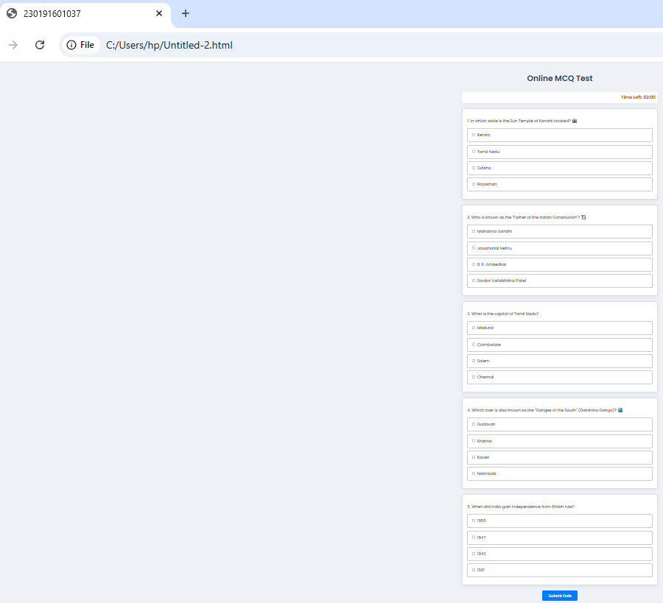

VIVA QUESTIONS :

RESULT

